Ideation Phase
Define the Problem Statements

Date | 11 September 2026
Project Name | Employee Raise Issue
Maximum Marks | 2 Marks

Customer Problem Statement Template:
The Employee Raise Issue application is designed to help employees report workplace concerns, IT issues, and service requests through a simple and structured process. The goal is to provide a centralized platform where requests can be submitted, tracked, and resolved efficiently, improving communication between employees and the support team
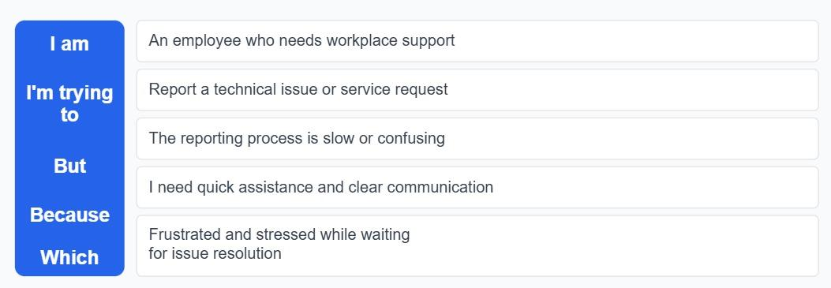

Example:
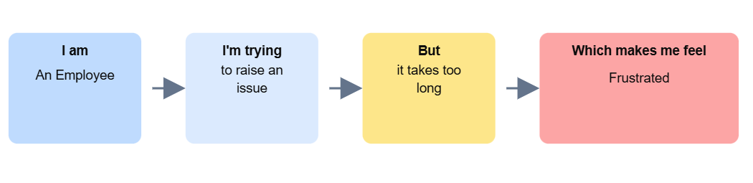

Problem Statement Table – Employee Raise Issue



